CS 255 System Design Document Template

This template lays out all the different sections that you need to complete for Project Two. Each section has guidance to prompt your thinking. You will need to continually reference the interview transcript as you work to make sure that you are addressing your client’s needs. There is no required length for the final document. Instead the goal is to complete each section based on what your client’s needs are. Remove this note when you are finished, and replace all bracketed text with the relevant information.

UML Diagrams

UML Use Case Diagram
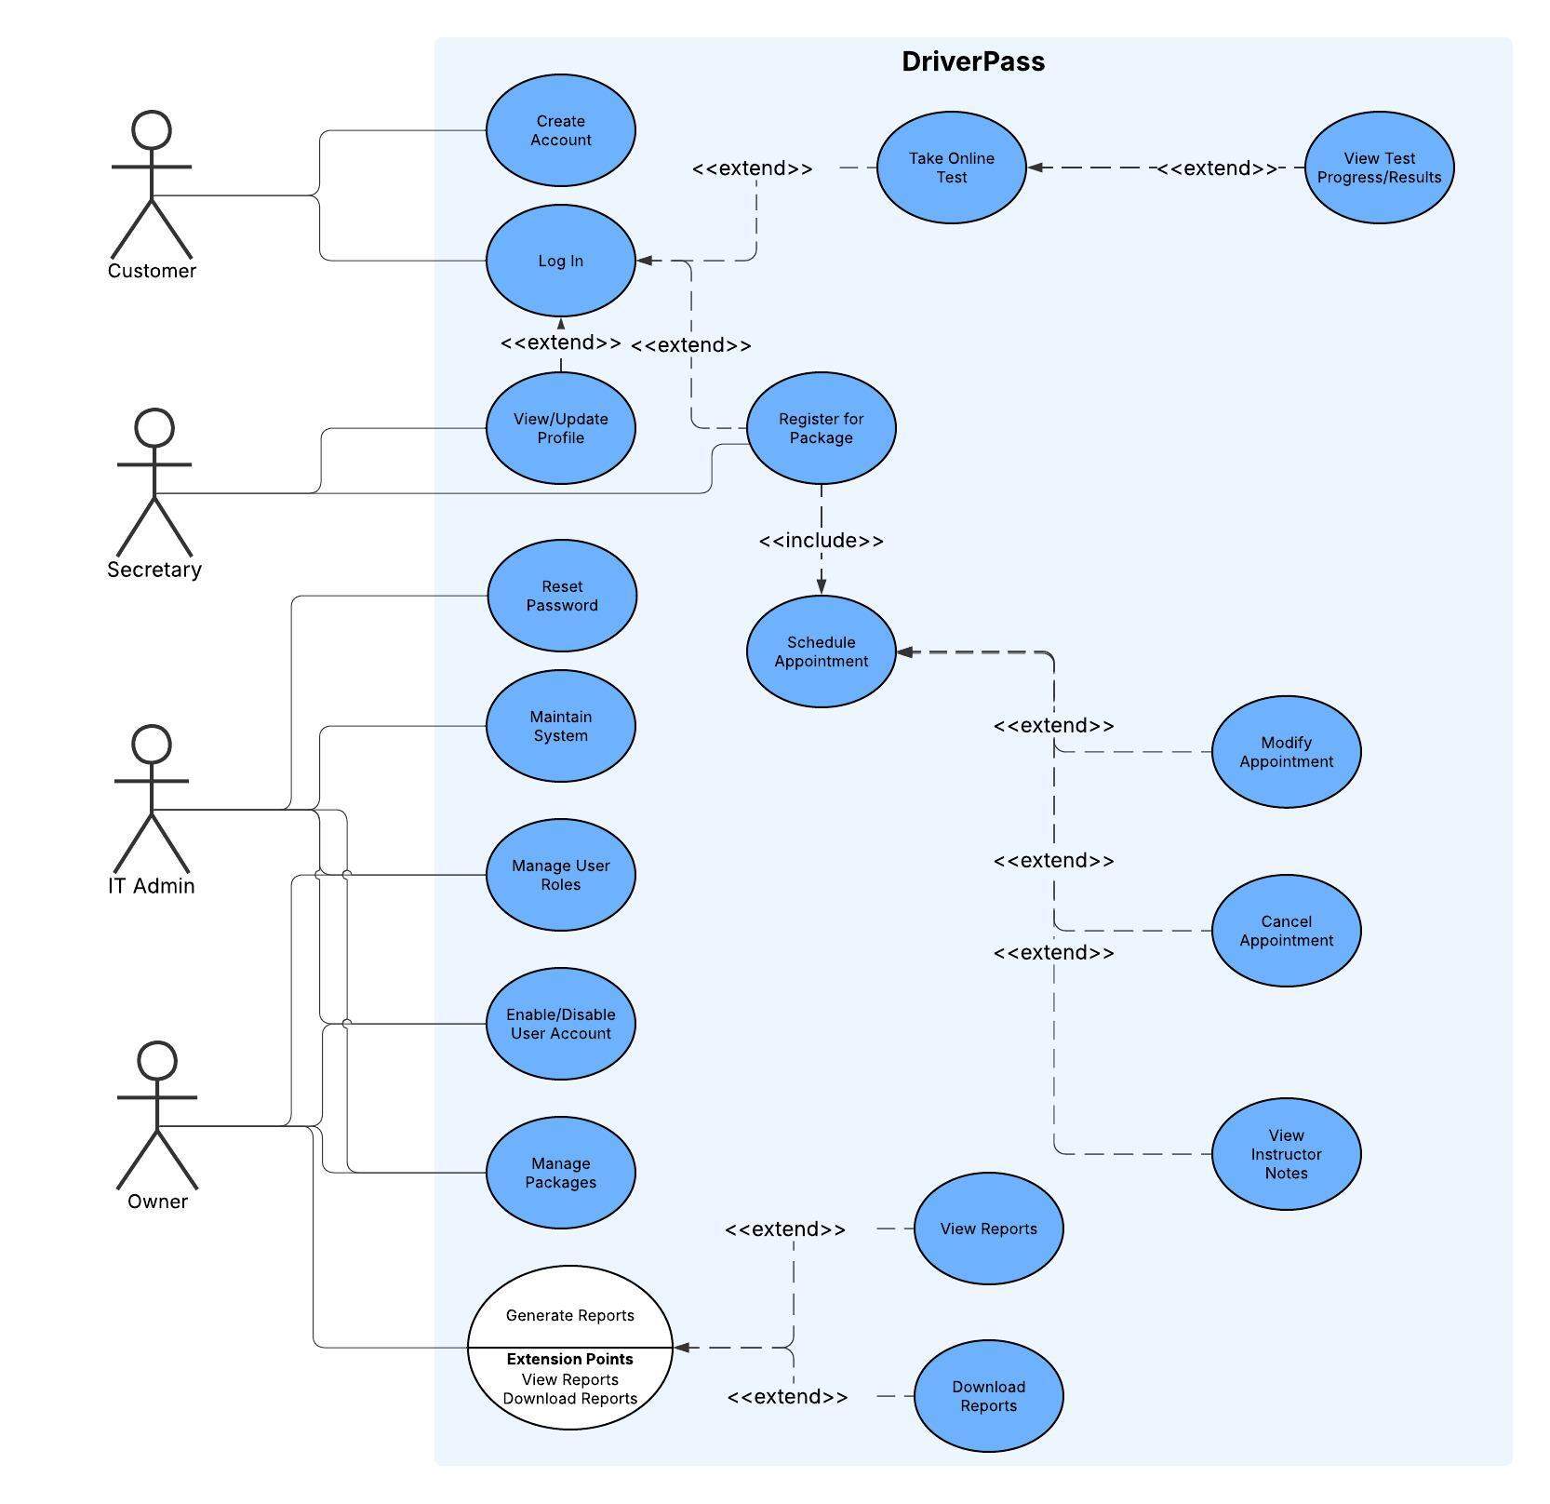

UML Activity Diagrams
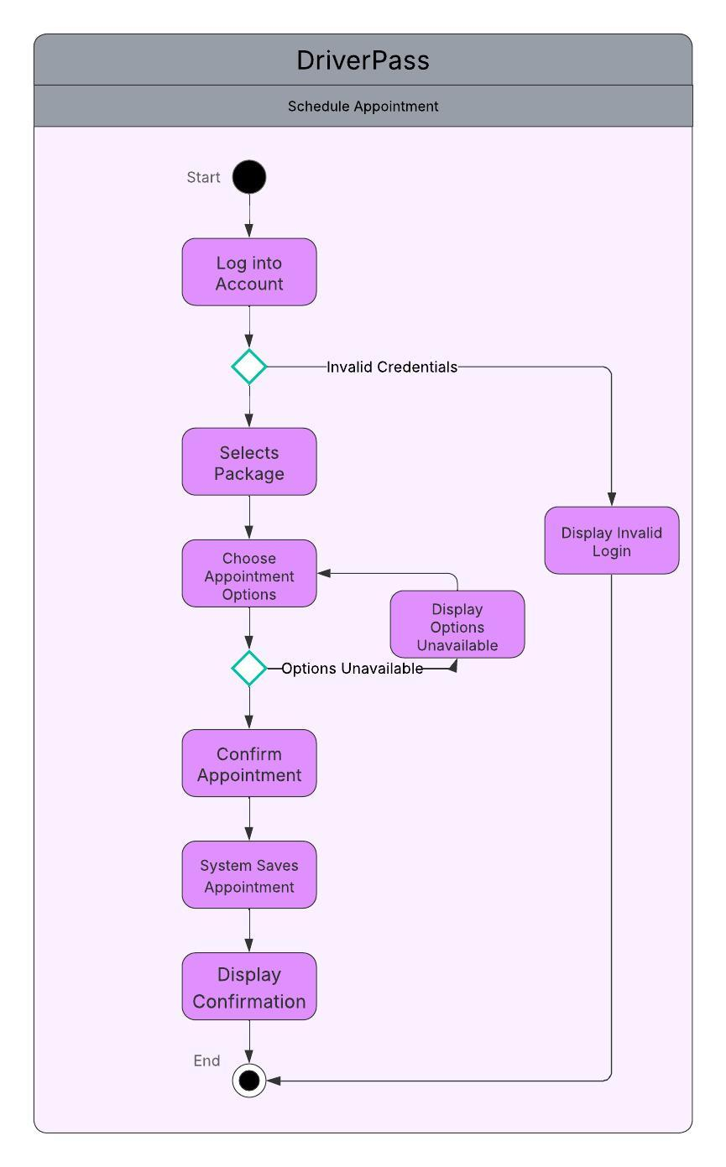
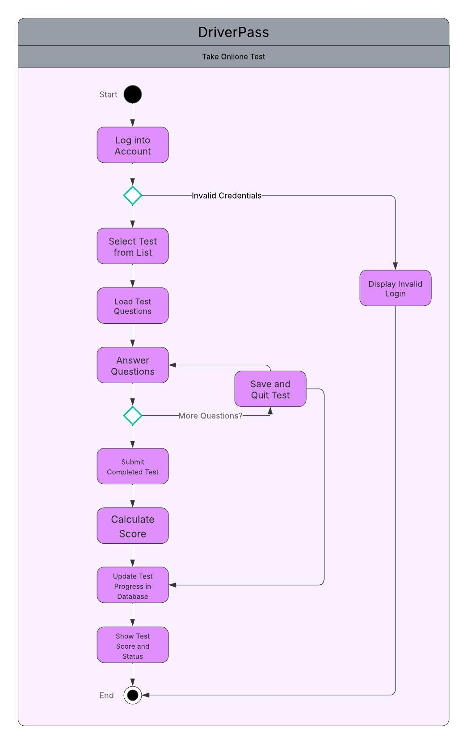

UML Sequence Diagram
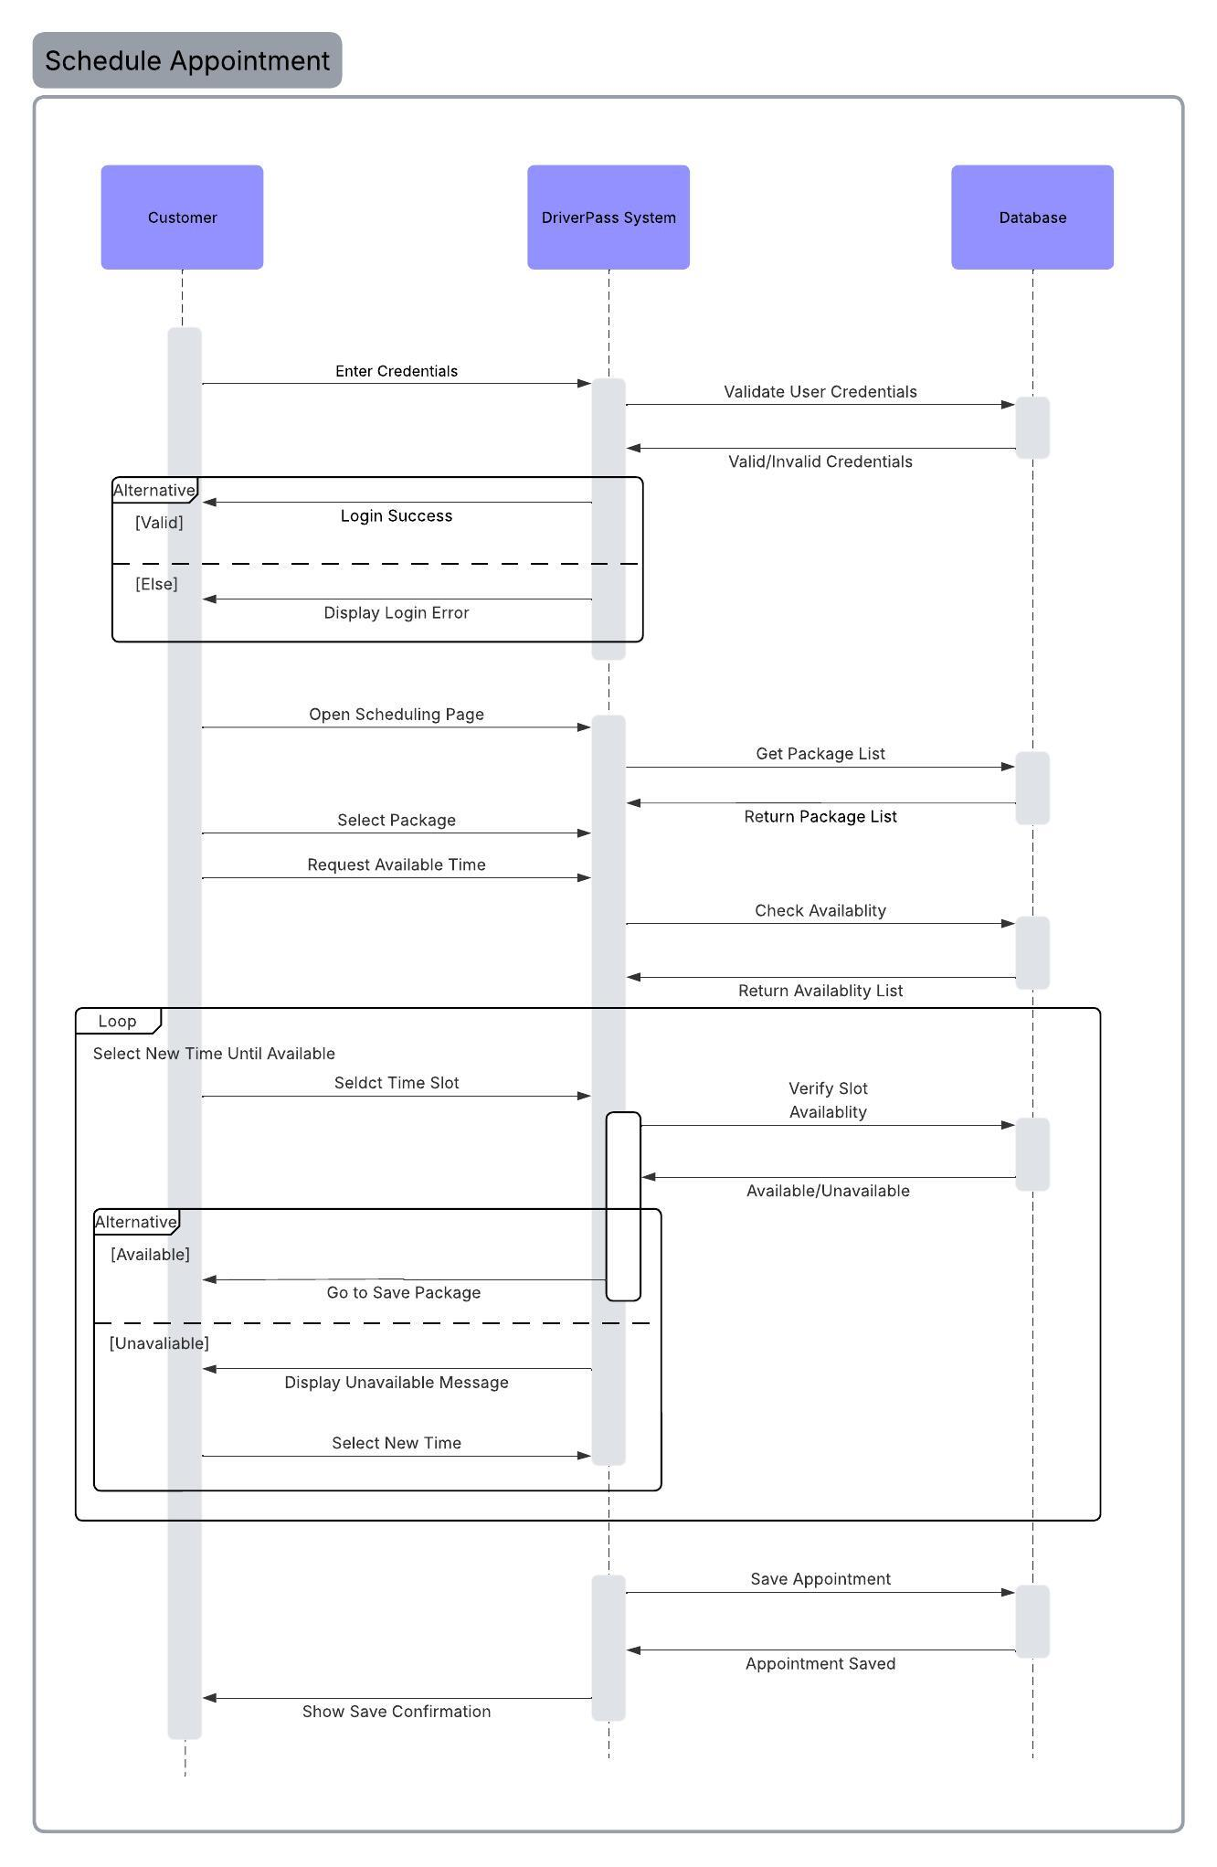

UML Class Diagram
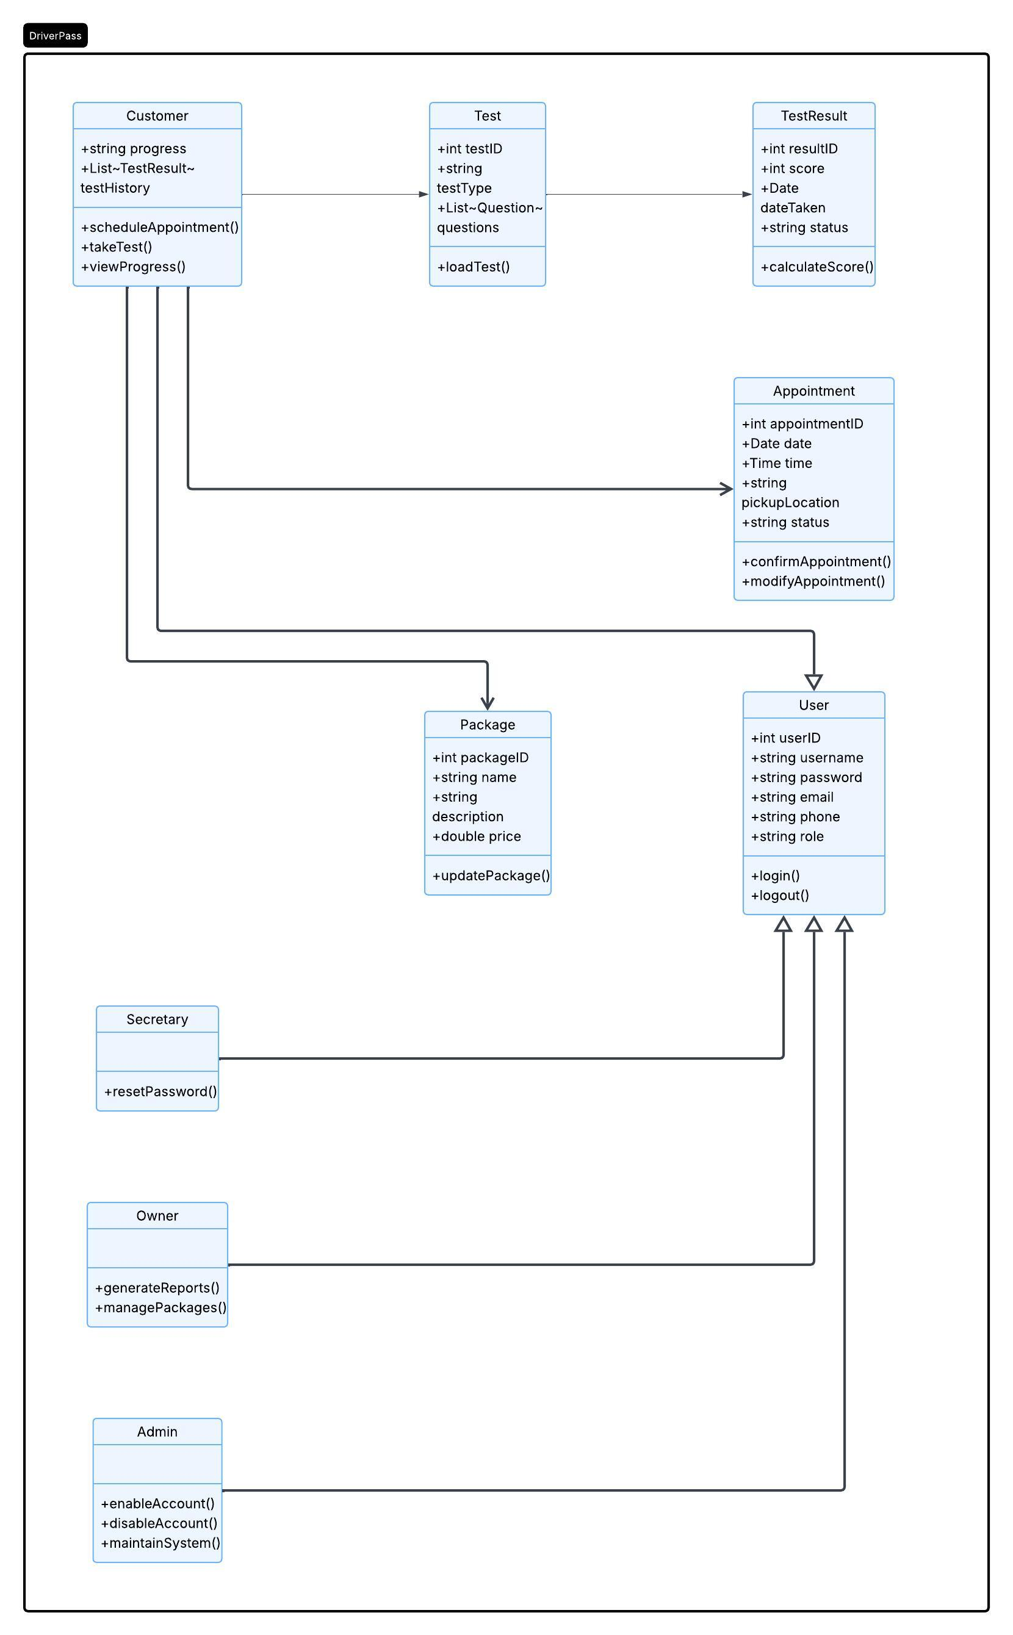

Technical Requirements
Hardware Requirements
On the server side, we will need to think about having concurrent users accessing the server at the same time. In order to make this possible, we will need a multi-core processor (at least 4 cores) and a minimum of 16GB of RAM. We will also need a database that can store up to 500 GB of data, preferably a solid-state drive (SSD), for quick data retrieval and system responsiveness. This could all be done by using a cloud services company like AWS or Azure. On the client side, they will need any modern desktop, laptop or mobile device to access the system.

Software Requirements
For our server-side software stack, we need a web server, a application runtime environment, a database management system and a secure software framework. Because of how well they work together and our team’s familiarity with them, I would suggest an Apache web server, a Java runtime environment, a PostgreSQL database and OAuth 2.0 authentication framework.
For the client-side, the user will need any modern web browser, such as Chrome, Edge or Safari. They will also need a JavaScript-enabled environment for the interactive portions of the app, like scheduling packages or taking tests. The app will be built on a responsive UI framework, like Vue or React.
To put this all together, we will need to use a version control system. I would suggest Git because it is so widely used and understood. We will also need a IDE to write our code in, and I would suggest IntelliJ because it works well with all the frameworks we have picked.

Security Requirements
To make sure our system is secure, we need to put in some security measures. We will need to make sure that all communication between the server and the clients are encrypted using HTTPS/TLS and that users’ passwords are stored secure using hashing and salting. Also, implementing the role-based access controls for the different app users (Customer, Secretary, Owner and Admin) will provide an extra layer of security.

Network and Infrastructure Requirements
The server-side environment should be hosted in the cloud, either AWS, Azure or something equivalent. We can also add a load balancer to help when there is high traffic periods. Finally we want to develop the system in a way that is scalable to help support future growth.

